RevMan practical (self-guided)

Study-centric data analysis
In this exercise you’ll use RevMan to explore the effect of Vitamin D for the management of asthma compared to placebo.
You’ll learn how to use the study-centric data feature of RevMan to generate forest plots that analyse the effect of Vitamin D on preventing one or more asthma exacerbations, to differing degrees of granularity.

Here’s how you do it:
You will need a laptop and internet connection. You will also need the following files:
- Study information file (Study information - Data extraction Vitamin D for management of asthma.csv)
- Study arms file (Vitamin D for the management of asthma.csv)
- Study results file (Vitamin D for the management of asthma.csv)

Step 1. Create a practice review in RevMan
Use the following link to create a practice review called ‘Vitamin D for management of asthma’: https://revman.cochrane.org/#/createPracticeReview/485723031508431008?key=44efc13c337b83ba
You will be prompted to log in with your Cochrane account (you can register for free if you haven’t done it already).
You will have access to the practice review for 30 days, if you want return to your practice review at a later date – you can access it by logging into RevMan here: https://revman.cochrane.org/#/myReviews
Note that you can have only a single practice review in RevMan. If you already have a practice review created from before, you will need to delete it to create a new one for this exercise. You can do so by clicking on the ‘My Reviews’ tab in RevMan and deleting the old review in the ‘Practice review’ section.

Step 2. Set up the Review criteria
This step is about defining the scope of the review and describing the PICO elements you will use when setting up individual analyses.
Click ‘Review criteria’ in the left-hand menu to open the window. Notice there are tabs to define each of the following:
- Interventions
- Intervention groupings
- Outcomes
- Covariates
- Characteristics and Risk of bias

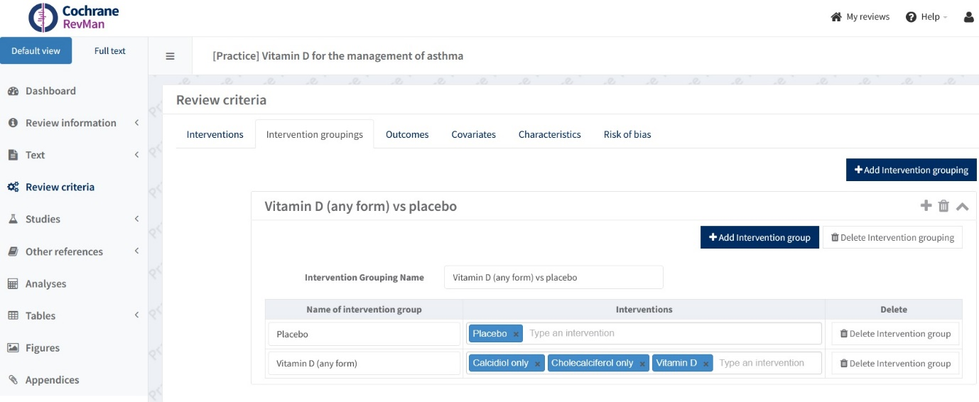
In this practice review the PICO elements are already defined for you.
Take a moment to review and understand each one. For example, you will see that in the ‘intervention groupings’ tab the Intervention group named ‘Vitamin D (all forms)’ includes not only Vitamin D, but also Cholecalciferol only and Calcidiol only.
This will allow you to set up different analyses that include studies with some or all of the interventions listed in the group. We’ll experiment with this in step 4.
Step 3. Create an analysis group
If this is the first time you are setting up an analysis group in your practice review - open the analyses section by selecting it from the left-hand menu. Press the button ‘Add Analysis group’.

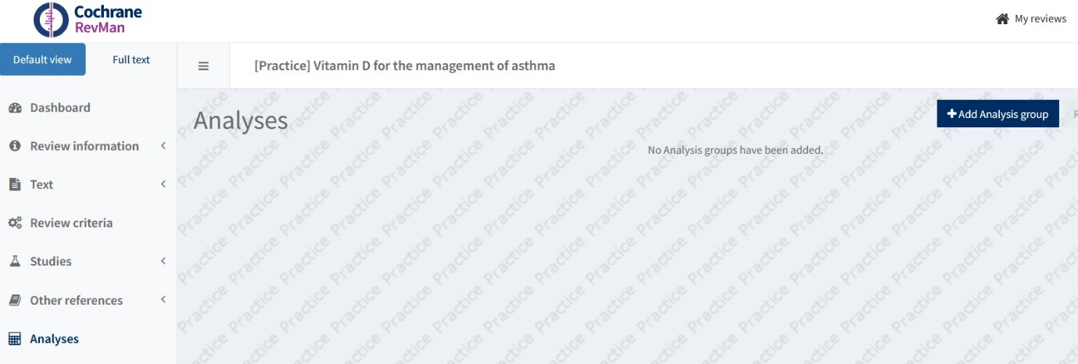

Name the analysis group ‘Vitamin D vs placebo’. Then Press ‘Back to Analyses’ to return to the analyses section.
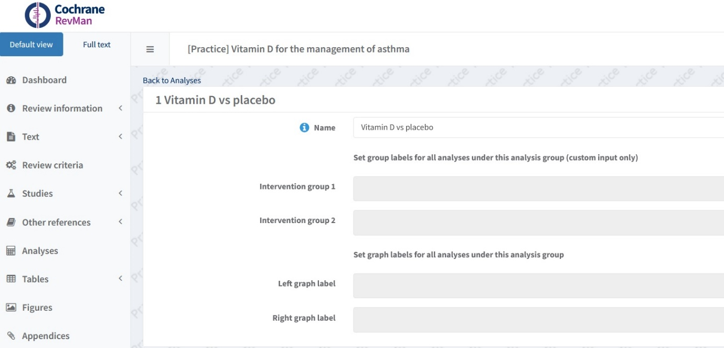

Step 4. Set up the analyses (with different levels of intervention granularity)
In this exercise we will examine the effect of Vitamin D on one or more exacerbations of asthma, using different levels of intervention granularity. You will set up two different practice analyses – follow the instructions in the examples below to find out how to do it.

Example 1: Vitamin D (any form) vs placebo
In this example we’ll examine the effect of any form of vitamin D on the outcome of interest ‘one or more exacerbations’, compared to placebo.
Start by adding an analysis to the analysis group you created in step 4. To do so, click the button ‘+ Add Analysis’ and a pop up box will appear. Select ‘automatic’, then press ‘OK’.

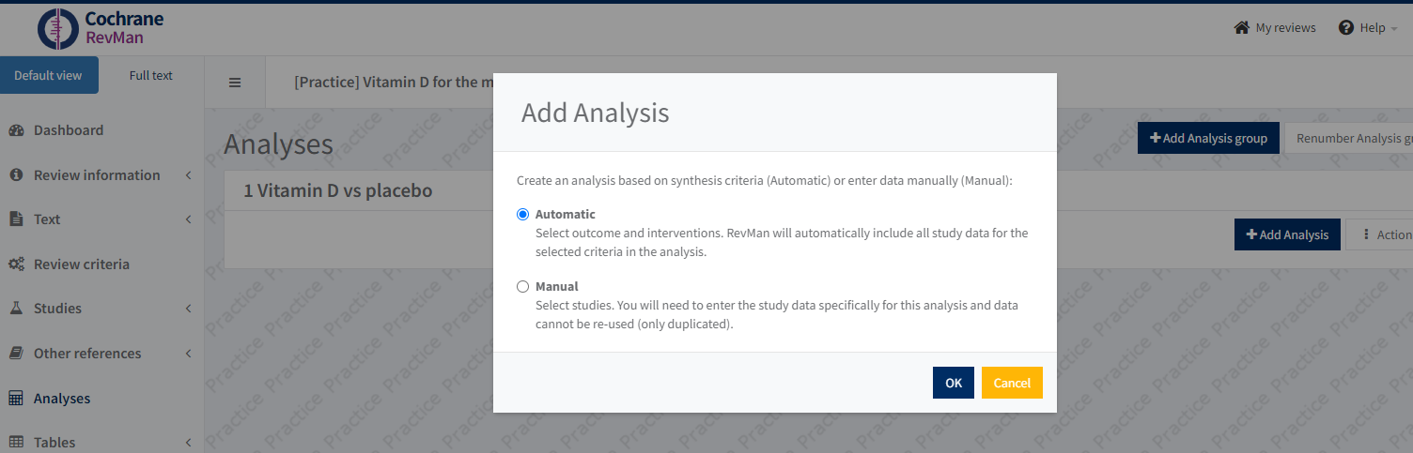
This will open the analysis window where you can set the analysis parameters and view the resulting forest plot for your example analysis.
Go to the ‘Options’ tab to set the parameters of the analysis.
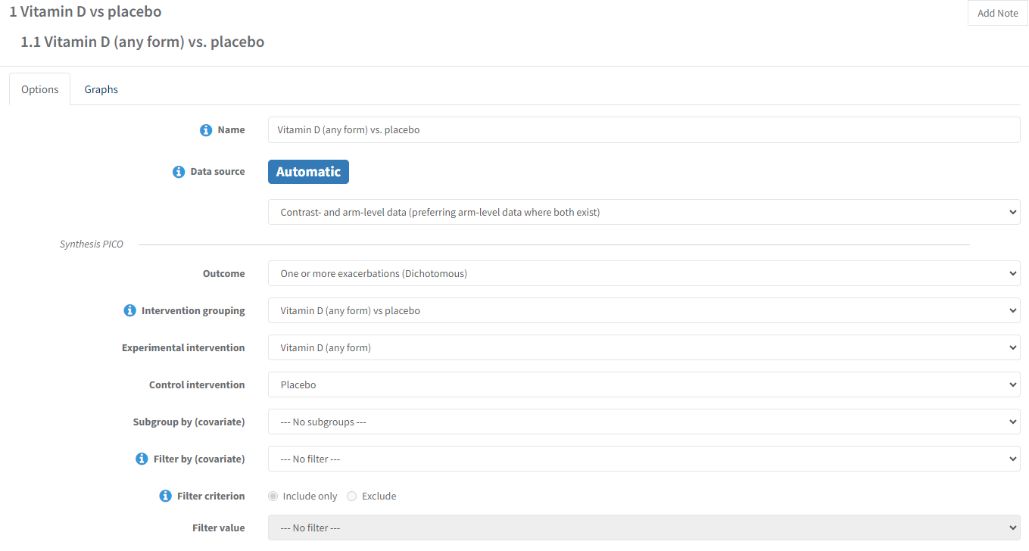
Name the analysis ‘Vitamin D (any form) vs placebo’
Under data source, select ‘Contrast- and arm-level data’ [preferring arm-level data where both exist]’. This is because we want to be as inclusive as possible in this analysis.
In the ‘synthesis PICO’ you select from the different PICO criteria we set in step 2. So, in this example choose the following parameters from each drop-down box:
Outcome = one or more exacerbations (dichotomous)
Intervention grouping = Vitamin D (any form) vs placebo
Experimental intervention = Vitamin D (includes all forms, as defined in synthesis PICO)
Control intervention = Placebo
Do not apply optional ‘filter by (covariate)’ or ‘subgroup by (covariate)’ settings.
For the statistical settings use:
Statistical method = inverse variance (the only one available when both contrast- and arm-level data are being used)
Effect measure = odds ratio
Analysis model = Random effects
Totals = Totals and subtotals
Study confidence interval 95%
Total confidence interval 95%

Example 2: Cholecalciferol only vs placebo
Now, let's assume you are only interested in the effect of cholecalciferol (Vitamin D3). You will set up a new analysis to explore that.
Create a new analysis by going back to the analyses section, click ‘add analysis’ in your existing analysis group, and select 'automatic' when prompted.
This time name the analysis ‘Cholecalciferol only vs placebo’ and select the same data source you used in example 1 (Contrast- and arm-level data [preferring arm-level data where both exist]).
In the synthesis PICO you’ll keep most of the settings the same as in the previous example but will have ‘cholecalciferol only’ as the experimental intervention and no intervention grouping. Therefore choose the following parameters:
Outcome = one or more exacerbations (dichotomous)
Intervention grouping = none
Experimental intervention = Cholecalceiferol only
Control intervention = Placebo
Do not apply optional ‘filter by (covariate)’ or ‘subgroup by (covariate)’ settings.
The statistical settings are the same as the previous example, i.e.:
Statistical method = inverse variance
Effect measure = odds ratio
Analysis model = Random effects
Totals = Totals and subtotals
Study confidence interval 95%
Total confidence interval 95%

Step 5. Import the study data for this exercise
In a real review that uses study centric data approach, we recommend setting up all the analyses first (during the protocol stage), and later just importing the data needed for these analyses (at the full-text stage). That’s why importing the study information in this practice exercise comes after you have set up your analyses.
To import the study information, select ‘Dashboard’ on the left-hand menu, then ‘Import study data’ in the dashboard window.
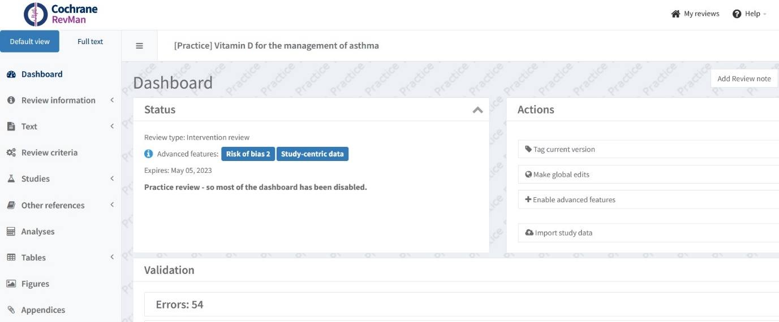

This will open the study data window.
In item 1 (extract study data) select ‘import from template’, then in item 3 (study information) upload the three files named:
- Study information - Data extraction Vitamin D for management of asthma.csv
- Study arms – Vitamin D for the management of asthma.csv
- Study results – Vitamin D for the management of asthma.csv
Press the button ‘import study data’ in the top right of the window. Then when the pop-up appears press ‘ok, continue’ to confirm you want to import the study data. You should see that 16 studies have been imported (you can also go to ‘Studies’ in the left-hand menu to check that the studies have all been imported.)
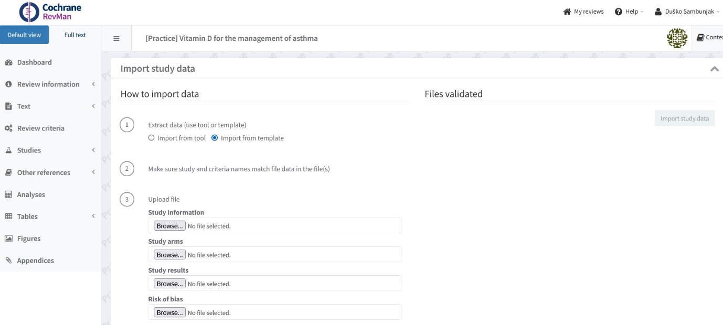
Step 6. View the forest plots
If all the data has been imported correctly, the forest plots will be automatically generated based on the analyses you've set up. To see them, go to 'Analyses', select the analysis you want to view, and click on the 'Graphs' tab to view your forest plot. A more detailed description of how to do this are shown in the worked examples below.
Example 1: Vitamin D (any form) vs placebo
So to view the forest plot for example 1 - go back to ‘Analyses’ in the left-hand menu, select the first analysis ‘Vitamin D (any form) vs placebo.

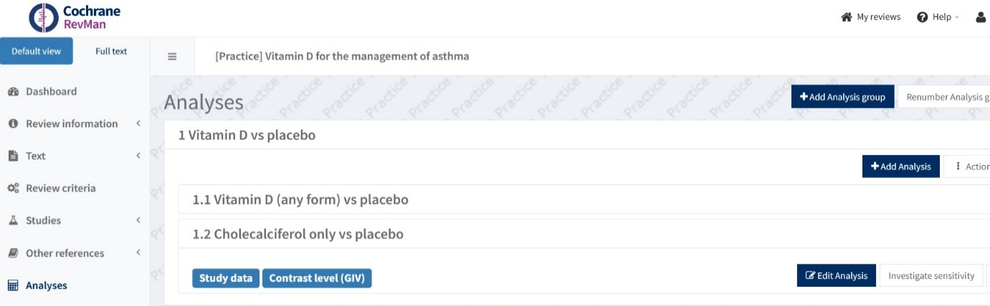

In the analysis window that opens, click the ‘Graphs’ tab
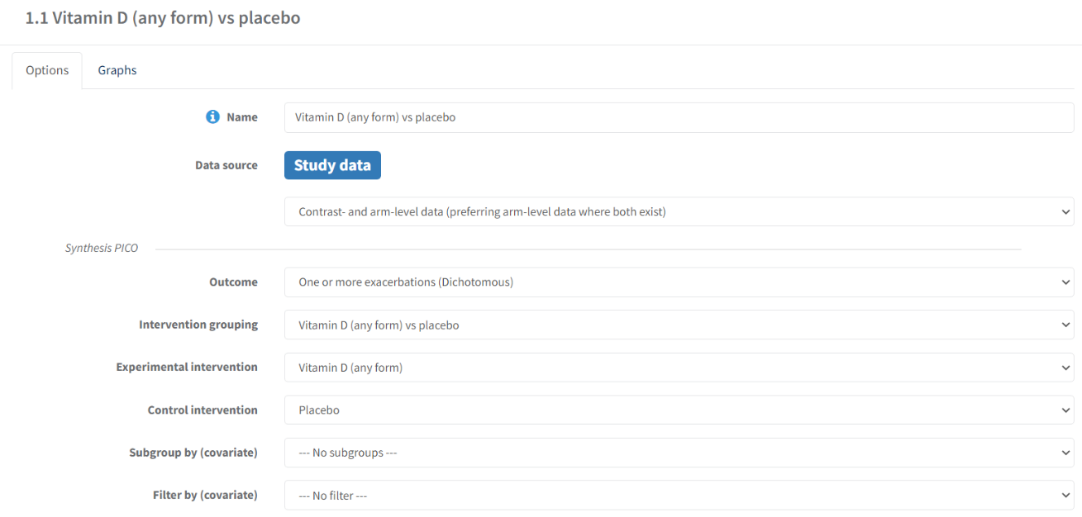
The forest plot will then appear:
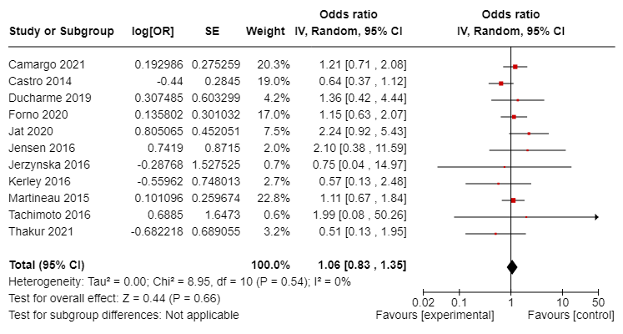

Example 2: Cholecalciferol only vs placebo
Follow the same process described above, to view your second analysis ‘Cholecalciferol only vs placebo’ and this is the forest plot you should see:
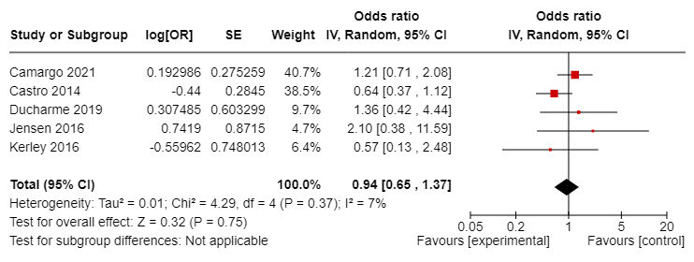

Further information
More information can be found in the RevMan Knowledge Base , especially in the section on study-centric data: https://documentation.cochrane.org/x/WRH-Bg

Note that ‘Characteristics’ and ‘Risk of bias’ are additional tabs which are not directly related to Review criteria (PICO), so they are not important for this exercise.
Note – you cannot name Intervention groups here as these are only used for custom input - not study centric data analysis. The graph labels can only be edited once you create an analysis within this analysis group.

